Big Data Analytics
5. Finding Similar Items and Clustering
5.1 Distance Measures: Definition of a Distance Measure, Euclidean Distances, Jaccard Distance, Cosine Distance, Edit Distance, Hamming Distance.
5.2 CURE Algorithm, Stream-Computing, A Stream-Clustering Algorithm, Initializing & Merging Buckets, Answering Queries.
PAST QUESTIONS:
- Explain CURE algorithm. (D23, M24, M25)
- Explain with example two major classes of distance measures. (D23)
- Distance measures for Big Data. (M24)
- Explain CURE algorithm with its advantages over traditional clustering algorithm. (D24)
- List and explain Distance measures for Big Data. (M25)

NOTES:

*Distance Measure :-
Distance measures in data science refer to algorithms that quantify the similarity or dissimilarity between two or more objects. These algorithms are commonly used in a wide range of data science applications, including clustering, classification, recommendation systems, and more.
Measures of distance are mathematical functions used to quantify how similar or dissimilar two objects are based on their features. These measures are critical for clustering, classification and information retrieval because they help determine relationships among data points.
Smaller distance = higher similarity, larger distance = higher dissimilarity.

1. Euclidean Distance –
Euclidean Distance is defined as the distance between two points in Euclidean space.
Euclidean distance is considered the traditional metric for problems with geometry. It can be simply explained as the ordinary distance between two points. It is one of the most used algorithms in the cluster analysis.
Euclidean distance is like measuring the straightest and shortest path between two points.
Formula –
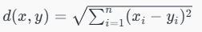
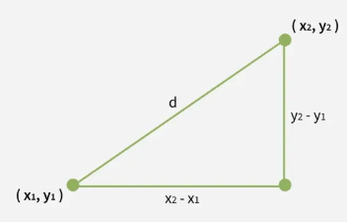
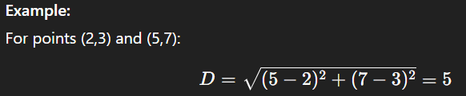
2. Jaccard Distance –
The Jaccard distance is set-based distance that compares dissimilarity by looking at the ratio of unique to common elements.
Jaccard Distance measures dissimilarity between two sets.
Common in binary or categorical data
Jaccard Distance is defined as the ratio of the intersection of the sets to their union:
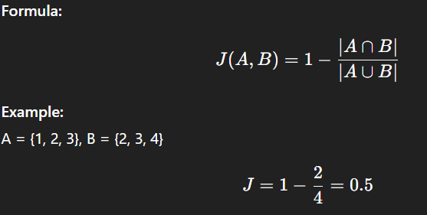
3. Cosine Distance –
Measures the cosine distance of the angle between two vectors, focusing on orientation rather than magnitude.
Measures the angle between two vectors instead of their magnitude.
Useful for text mining and recommendation systems.
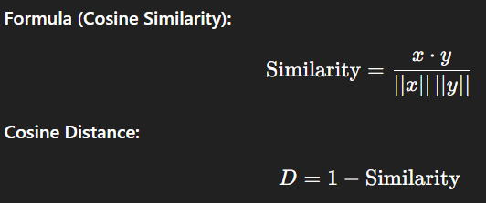
4. Hamming Distance –
Counts the number of positions where two strings of equal length differ. Used for binary strings or categorical attributes.
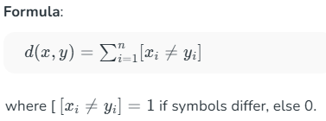
5. Edit Distance –
Calculates the minimum number of insertions, deletions, or substitutions to transform one string into another.
Edit Distance is a measure of how dissimilar two strings (text sequences) are,
by counting the minimum number of operations required to transform one string into another.

*CURE Algorithm :-
The CURE (Clustering Using REpresentatives) algorithm is a hierarchical clustering technique designed for large databases, particularly effective in identifying clusters of arbitrary shapes and handling outliers. It addresses limitations of centroid-based algorithms (like K-means) and all-points based algorithms by adopting a middle-ground approach using representative points.
Hierarchical clustering is a type of clustering, that starts with a single point cluster, and moves to merge with another cluster, until the desired number of clusters are formed.
It is used for identifying the spherical and non-spherical clusters.
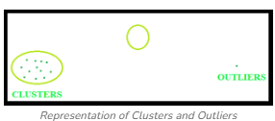
Instead of using one point centroid, as in most of data mining algorithms, CURE uses a set of well-defined representative points, for efficiently handling the clusters and eliminating the outliers.
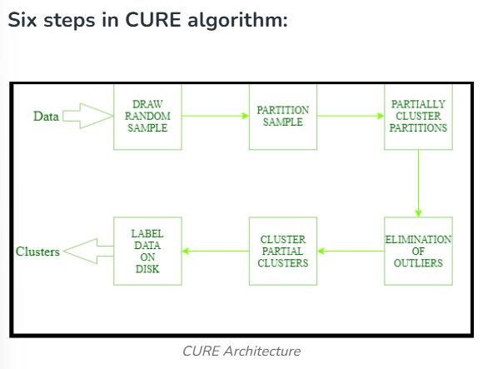
Working –
- Random Sampling:
A random sample of data points from the large dataset is taken and loaded into main memory. This significantly reduces the processing time for large datasets.
- Initial Clustering:
The sampled data points are then clustered hierarchically to form initial clusters.
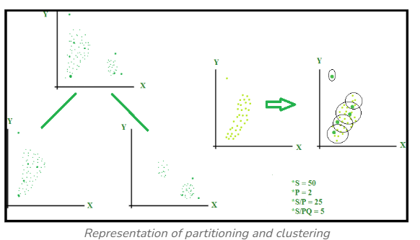
- Representative Point Selection:
For each of these initial clusters, a fixed number of representative points are chosen. These points are selected to be well-dispersed within the cluster, capturing its overall shape and structure.
- Shrinking Representative Points:
To mitigate the effect of outliers and noise, these representative points are "shrunk" towards the centroid of their respective clusters by a certain percentage (e.g., 20%). This process helps to make the cluster representatives more robust.
- Assigning Remaining Data:
In the second pass, the entire dataset is scanned. Each remaining data point (those not in the initial sample) is assigned to the cluster whose representative point is closest to it. The distance is typically measured using Euclidean distance.
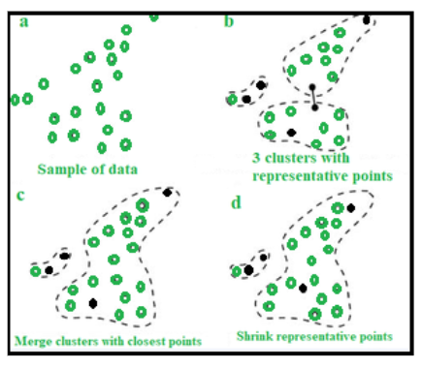
Advantages –
- Handles Arbitrary Cluster Shapes:
Unlike K-means which primarily finds spherical clusters, CURE can identify clusters of various non-spherical and complex shapes.
- Robust to Outliers:
The shrinking of representative points towards the cluster centroid helps to reduce the influence of outliers.
- Scalable for Large Datasets:
The use of random sampling and a two-pass approach makes CURE efficient for big data applications.
- Hierarchical Nature:
It provides a hierarchical structure of clusters, allowing for analysis at different levels of granularity.

